**COMP 526 HW6**

Mo Tang mt60

Experiment 1.

I.

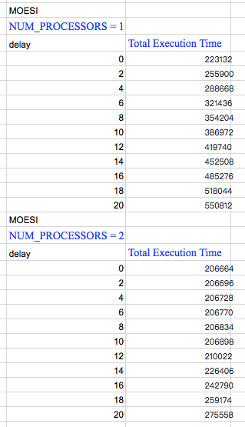

II.

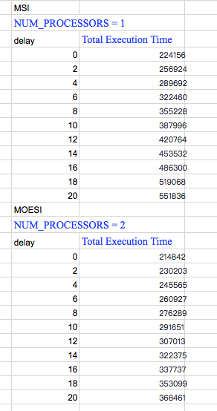

III.

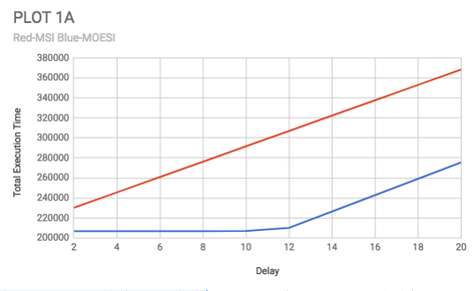

IV.

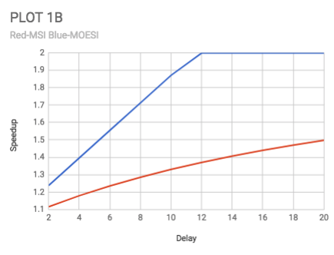

V.

We can see from the plot that the execution time of MOESI protocol is longer than that of MSI protocol. And when it comes to speedup, MOESI goes to 2 quicker than MSI.

Experiment 2.

III.

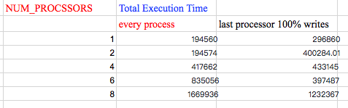

IV.

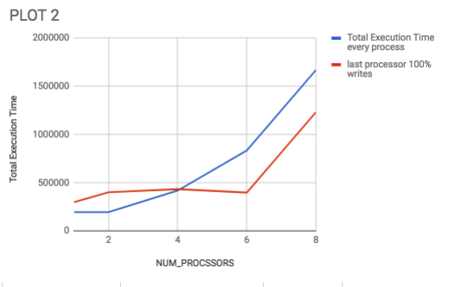

V.

The execution time of blue curve is longer, as it will take 100 cycles to read from the memory, with no cache-to-cache the processor reads directly from memory. For the last processor 100% write, when it writes back to cache block, the state is M. For bus_rd, the state is O.When num_processors reach 8, the execution time will increase, because cache block has 8 integers.